**CS 628 Full-Stack Development II**

**HOS01F Web Application without Express**

July 16, 2020

12/29/2020 Updated by Min

School of Technology & Computing (STC)

City University of Seattle (CityU)

**Before You Start**

* The directory path shown in screenshots may be different from yours.
* This HOS does not explain all steps in detail**.** If you are not sure what to do:
  1. Consult the resources listed below.
  2. If you cannot solve the problem after a few tries, ask a TA for help.

**Resources**

* About Node.js, <https://nodejs.org/en/about/>
* Holmes, S. & Harber, C. (2019). [Getting MEAN with Mongo, Express, Angular, and Node, Second Edition](https://login.proxy.cityu.edu/sso/skillport?context=148121). Manning Publications. (ISBN 9781617294754)
  + Appendix B: Installing and Preparing the Supporting Cast
    - Section: Setting up Heroku

**Learning Outcomes**

Students will be able to:

* Understand a native node web application without Express.
* Analyze a native node application.

**Activities**

* Preparing for a MEAN project environment
* **Experiencing a native Node web application**
* Pushing your work to GitHub
* Deploying your work to Heroku

**Preparing for a MEAN project environment**

1. Create the “module01c” folder under your repo:  
   >>>mkdir module01c  
   you will see like that:



1. Open the “module01c” folder in the VSCode.  
   Close the “Welcome” window.  
   Open the terminal (Ctrl+`).

**Experiencing a native Node web application**

1. Create a file appA.js.
2. Copy the code from About Node.js at <https://nodejs.org/en/about/>.  
   Then, execute the code.  
     
   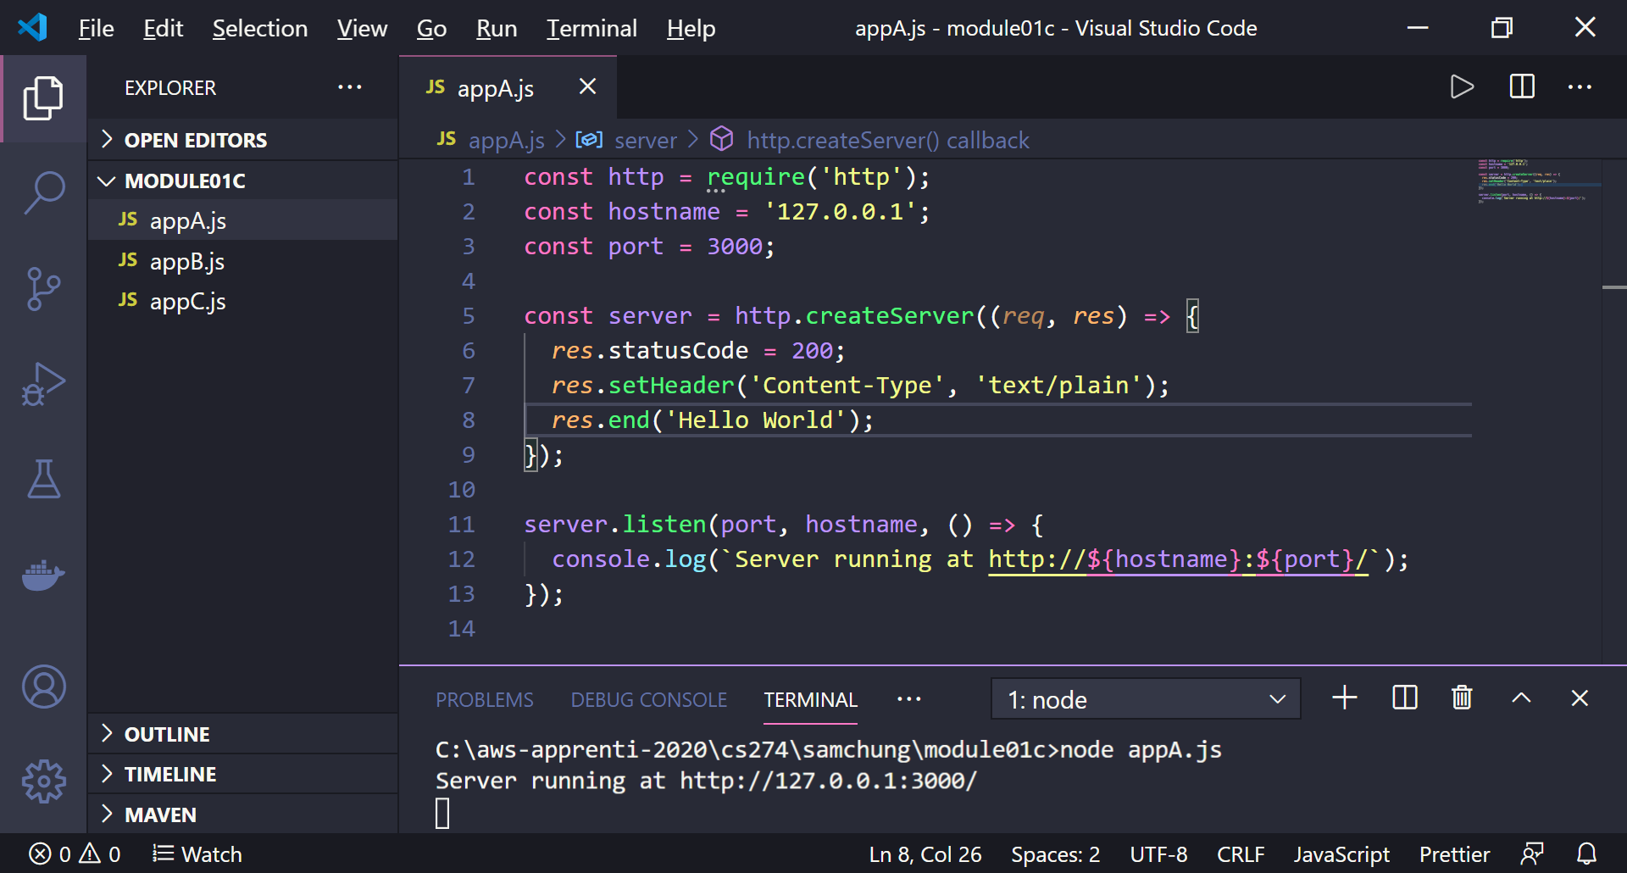
3. Click the <http://localhost:3000> from the terminal or copy and paste it to your browser.  
   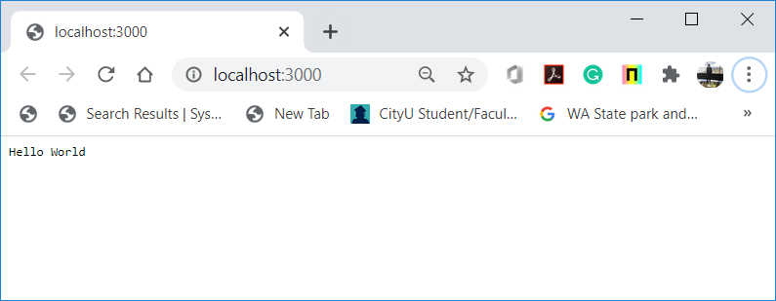

Now your first web server is running. ☺ Please hit the control + c key to quit the server.

1. Analyze the source code to understand how it works.
2. Create a file appB.js by copying appA.js.
3. Instead of playing a plain text file, we will display a web page.  
   Please update the part in the red box.  
   Then, execute the code.  
     
   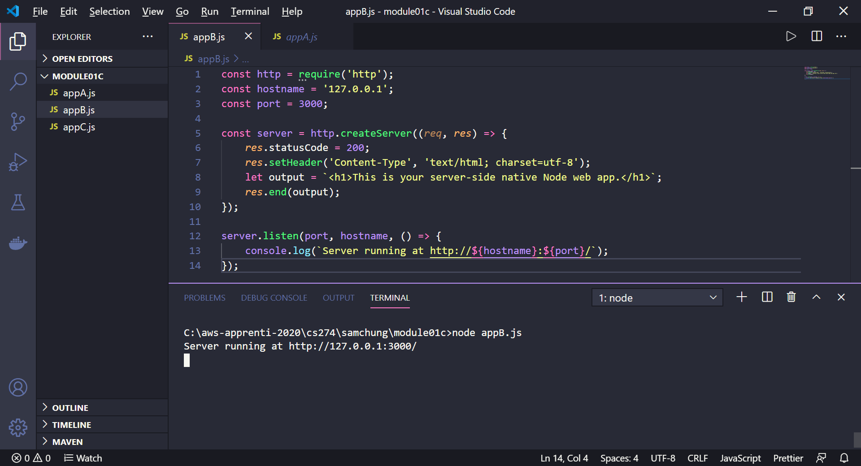
4. Click the <http://localhost:3000> from the terminal or copy and paste it to your browser.  
   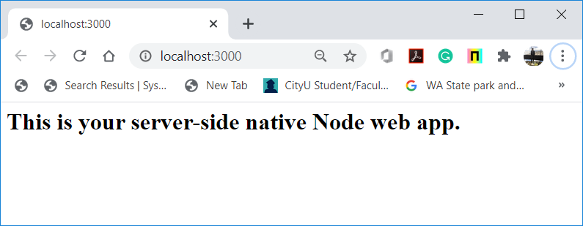
5. Analyze the source code to understand what part was changed and how it works.
6. Create a file appC.js by copying appB.js.
7. Visit the client-side JavaScript application in HOS01D.  
   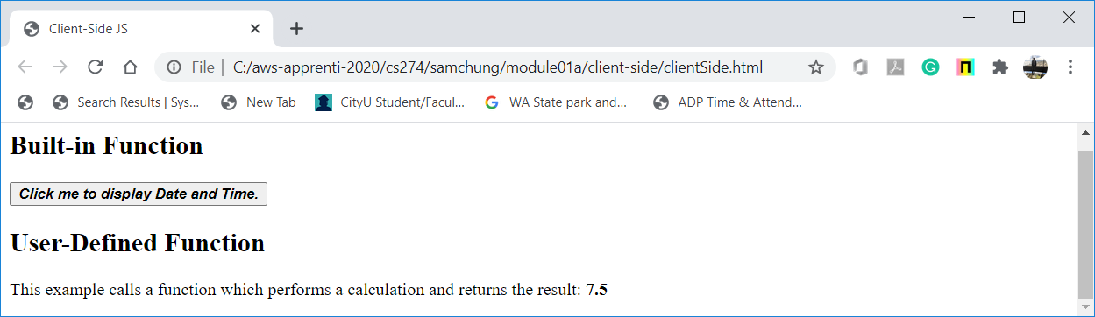
8. Implement the user-defined function in the appC.js file.  
   Then, execute the code to generate the following output.  
     
   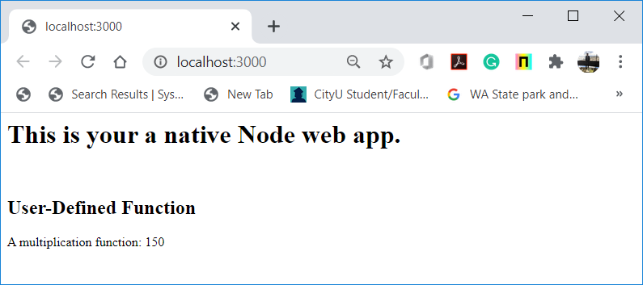
9. Analyze the source code to understand what part was changed and how it works.

**Pushing your work to GitHub**

Run the following commands to push your work to the GitHub repository:

Open the terminal from the VSCode by hitting the control + ~ key and type the following command:

>>> git add .

>>> git commit -m “Submission for Module 1 --yourname”

>>> git push origin master

If you cannot remember your branch name, run the command “git status” to check.

**Creating a pull request**

* Go to the remote repository in GitHub